Presentation to Pinner Philosophy Group
1st October 2025 -Alexis and Richard
Carl Jung - Analytical Psychology: the Self, the Shadow and Archetypes
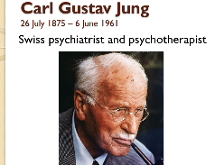
Jung Presentation Alexis’ colour – Richards’ colour
Slide 1
Carl Gustav Jung was one of the pioneering figures of the 20th century. He was an intellectual giant, a radical and inspirational thinker who developed a unique way of understanding the human psyche and its functioning.
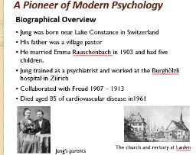
Slide 2 – Personal history
Jung was born in 1875, near Lake Constance in Switzerland. His father was a village pastor, something that gave Jung a unique insight into Christianity. He married Emma Rauschenbach in 1903 and had five children.
Jung trained as a psychiatrist and worked at the Burghölzli hospital in Zürich, where he came across Sigmund Freud’s work, in which he was immediately interested. After a period of correspondence, Jung became a pupil of Freud’s. They collaborated in setting up and popularising Freud’s psychoanalysis in its difficult early years, when this radical new understanding of the mind was meeting much opposition.
Jung was essentially interested in describing a practical psychology which properly addressed the range of difficulties of the people he met, both inside and outside his consulting room.
He saw the whole life cycle as a continuing process of metamorphosis which was regulated by the Self. He thought that the stages through which each human life proceeds are all an evolutionary extension of those observable in non-human species.
Throughout his long life Jung was a deeply introverted man, more interested in the inner world of dreams and images than in the outer world of people and events. He had a genius for introspection and that enabled him to have experiences below the level of consciousness of which most of us remain completely unaware.
Certain aspects of his background and childhood experiences affected him profoundly. His parents moved to two large vicarages in different parts of Switzerland when he was very young and he describes the family home as ‘unbreathable’. He says he was ‘oppressed with a pervasive sense of death, melancholy, and unease with ‘dim intimations of trouble between his parents.’ When he was 3 his mother had a mental breakdown and she had to spend several months in hospital, and this enforced separation at a critical stage of his development seems to have affected Jung for the rest of his life. During this time he was cared for by an aunt and a maid and he recalled being deeply troubled by his mother’s absence. He suffered from nervous eczema and had terrifying dreams. ‘from then on I always felt mistrustful when the word love was spoken. The feeling I associated with ‘’woman” was for a long time that of innate unreliability.’ This caused him to develop a defensive attitude of emotional detachment, to become self-absorbed and self-reliant to an unusual degree. He was rather odd and aloof in manner, and this did not endear him to others (Anthony Stevens).
Another childhood incident that left a profound effect on Jung was at school. He had written an essay which he took enormous care over but his teacher accused him of plagiarism but when he protested his innocence his class mates sided with the teacher. He was very unhappy at school and his odd and rather schizoid manner (meaning withdrawn, aloof and self-absorbed) made him unpopular and the school environment was one in which he couldn’t flourish. For a long period he dropped out altogether, having developed fainting attacks after a blow on the head when knocked over by another boy. After that he spent as much time as he could on his own. He said ‘On the whole, I liked that best. I played alone, daydreamed or strolled in the woods alone, and had a secret world of my own.’
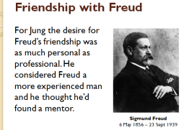
Slide 3 – Friendship with Freud
For Jung the desire for Freud’s friendship was as much personal as professional. He considered Freud a more experienced man and he thought he’d found a mentor. He was a father figure very different to his own father who wasn’t very intellectually capable. Jung wrote to Freud after their first meeting “let me enjoy your friendship not as one between equals but as that of father and son”. Freud responded at a later date by formally anointing Jung as his son and heir, his crown prince. In fact, Freud needed a son just Jung needed a father but the kind of son Freud wanted was one who would be willing to defer unconditionally to his authority to perpetuate his doctrines and principles. Although Jung basked in Freuds’ approval and was flattered to be considered his worthy successor, he knew he could not endorse Freud’s ideas completely. He nevertheless agreed to Freud’s wish that he should serve as the first president of the International Psychoanalytic Association when it was set up in 1910 and as chief editor of the first psychoanalytic journal the Jahrbuch.
As time passed Jung’s differences with Freud became harder to conceal. Two of Freud’s basic assumptions were unacceptable to him:
1. That human motivation is exclusively sexual
2. That the unconscious mind is entirely personal and peculiar to the individual
Jung found these and other aspects of Freud’s thinking reductionist and too narrow. Instead of regarding psychic energy (or libido as Freud called it) as wholly sexual, Jung preferred to think of it as a more generalised ‘Life force’ of which sexuality was only one mode of expression. Whenever he tried to express these ideas to Freud, Freud tried to attribute them to his youthful inexperience or to resistance. Freud said: “Don’t deviate too far from me when you are really so close to me, for if you do we may one day be played off against one another.” Freud admonished him, adding “My inclination is to treat those colleagues who offer resistance exactly as we would treat patients in the same situation.” It was inevitable that a row would eventually break out between them. Jung wrote to Freud, “It is a risky business for an egg to be cleverer than the hen. Still, what is in the egg must find the courage to creep out”. Also quoting from Zarathustra “One repays a teacher badly if one remains only a pupil.” They split irreconcilably in 1913.
Jung then went into 4 years of isolation where he initially doubted himself and was at a very low ebb psychologically. Yet, in later years he saw this time as a positive occurrence as it allowed him to work internally on his own ideas developing the concepts that were to become the cornerstones of analytical psychology.
In his Introduction to Jung book Anthony Stevens says “Jung was a man of paradox. In one sense he was an individualist, a great eccentric. In another he was the living embodiment of the universal man. He strove, in his own life to realise his own human potential. But he was determined, at the same time to live in an uncompromisingly unique way. If this meant upsetting people, as was often the case, he did not seem to mind. He said ‘to be normal is the ideal aim of the unsuccessful.’”
Although he considered himself to be a rational scientist, he was interested in matters conventionally considered to be irrational or esoteric and he took no notice if these interests were unacceptable to the scientific establishment. He had to keep faith with the truth as he saw it and wrote ‘I feel it is the duty of one who goes his own way to inform society of what he finds on his voyage of self-discovery.’
Anthony Stevens says: “The sense of being drawn by destiny to swim against the prevailing tide makes him a richly intriguing character”.
Jung’s understanding of humanity grew out of his understanding of himself. (Questions & Discussion)
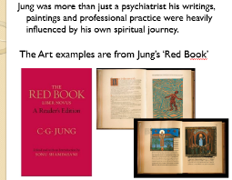
Slide 4 – The Red Book
The Red Book was a form of personal diary for Jung in which he documented his work especially his inner ponderings. It includes many images he created that came to him during these inner journeys. He refused to be called an artist and considered these images as renderings of the images from his deep personal life. He was very protective of this diary and only showed it to a limited number of people. It was only published by his family in 2009 many years after his death. Jung hadn’t published it as he considered is unscholarly and thought people would think him a crazy mystic.
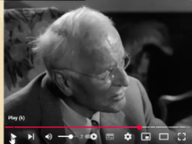
Slide 5 – In his own words – (available on UTube)
An excerpt from the 1959 ‘Face to Face’ interview with John Freeman.
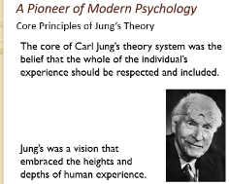
Slide 6- A Pioneer of Modern Psychology
The core of Carl Jung’s theory system was the belief that the whole of the individual’s experience should be respected and included, rather than aspects being pathologised or disavowed; this included the individual’s unwanted ‘shadow’ aspects – such as, for example, their aggressive, envious, destructive qualities, as well as their spiritual longings and experiences. Jung’s was a vision that embraced the heights and depths of human experience.
The most famous idea of Jung’s is his recognition of the psychological value of spiritual experience, particularly in an era where traditional religious belief was waning and church attendance across Europe was declining. Jung recognised that these spiritual longings, beliefs and experiences stemmed from the psyche’s intrinsic striving toward wholeness, which required that the individual move beyond, and expand, their everyday view of themselves, opening themselves up to the functioning of the deeper psyche and the working of what he called ‘the self’.
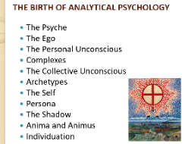
Slide 7 - THE BIRTH OF ANALYTICAL PSYCHOLOGY
Analytical psychology is the term that Jung gave to his particular form of psychotherapy. His views evolved over many years so it is difficult to give a succinct summary of them but we hope you will grasp a general idea of his views.
He called this practical psychology, analytical psychology, and it is sometimes also known as Jungian psychotherapy (or analysis). He delved into and developed areas which included, individuation and the self, the shadow, the personal and the collective unconscious, complexes and archetypes, the transcendent function, the theory of opposites, the self-regulating purposive psyche, the theory of types, introversion and extroversion, and the compensatory function of dreams.
He also had significant insights in regard to the working of the analytic relationship, drawing on mediaeval alchemical texts as a metaphor, and discussing the way in which analyst and analysand (the person in analysis) mutually influence the other. He coined the term the coniunctio (a Latin word meaning union or conjunction) to describe elements of this process. Jung also made other contributions to the study of religion, to philosophy and to theoretical physics, amongst other fields.
He considered alchemy not in transforming the physical but more in psychological terms, that is throwing out the unwanted behavioural patterns and replacing them with more balance. Put simply turning metal into gold within the human psyche. In other words it’s a purification and transformation process.
His interest in spiritual experience has sometimes led to a charge of Jung’s vision being essentially a mystical one. Whilst his understanding would certainly embrace mystical experience (he would want to be inclusive of all human experience).
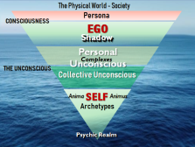
Slide 8 – the Self ‘Diagram’
This slide is an attempt to illustrate the subtle influences we experience as the totality of the conscious and unconscious aspects of the psyche. What it best illustrates is a comparison between our outer world and our inner world.
The Self will be discussed further when we deal with the Archetypes.
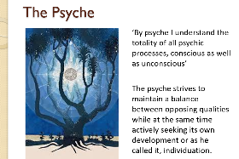
Slide 9 - The Psyche
Jung writes: ‘By psyche I understand the totality of all psychic processes, conscious as well as unconscious’, so we use the term ‘psyche’ rather than ‘mind’, since mind is used in common parlance to refer to the aspects of mental functioning which are conscious. Jung maintained that the psyche is a self-regulating system (like the body)’.
The psyche strives to maintain a balance between opposing qualities while at the same time actively seeking its own development or as he called it, individuation.
For Jung, the psyche is inherently separable into component parts which we will attempt to explain.
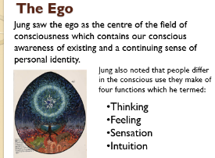
Slide 10 - The Ego
Jung saw the ego as the centre of the field of consciousness which contains our conscious awareness of existing and a continuing sense of personal identity. It is the organiser of our thoughts and intuitions, feelings, and sensations, and has access to memories which are not repressed. The ego is the bearer of personality and stands at the junction between the inner and outer worlds.
The way in which people relate to inner and outer worlds is determined by their attitude type:
- An extraverted individual being orientated to the outer world
- An introverted one primarily to the inner world
Jung also noted that people differ in the conscious use they make of four functions which he termed, thinking, feeling, sensation, and intuition. In any individual, one of these functions is superior and is therefore more highly developed than other functions, since greater use is made of it, but each attitude operates in relation to the introversion or extraversion of the person.
The ego arises out of the Self during the course of early development. It has an executive function, it perceives meaning and assesses value, so that it not only promotes survival but makes life worth living. It is an expression of the Self, though by no means identical with it, and the Self is much greater than it.
Jung compared the nature of consciousness to the eye: only a limited number of things can be held in vision at any one time, and in the same way the activity of consciousness is selective.
Selection, he says, demands direction and other things are excluded as irrelevant. This is bound to make conscious orientation one sided. The contents which are excluded sink into the unconscious where they form a counterweight to the conscious orientation. Thus, an increasing tension is created and eventually the unconscious will break through in the form of dreams or images. The difficulty with dreams though is that they primarily communicate in imagery making them often difficult to interpret.

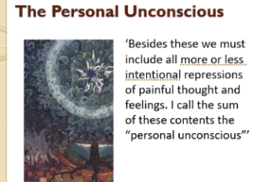
Slide 11 - The personal unconscious
The personal unconscious is a product of the interaction between the collective unconscious and the development of the individual during life. Jung’s definition of the personal unconscious is as follows:
- Everything about which I know, but of which I am not at the moment thinking
- Everything about which I was once conscious but have now forgotten
- Everything perceived by my senses, but not noted by my conscious mind
- Everything which, involuntarily and without paying attention to it, I feel, think, remember, want, and do
- All the future things which are taking shape in me and will sometime come to consciousness
- All this is the content of the ‘Unconscious’.
Quote: ‘Besides these we must include all more or less intentional repressions of painful thought and feelings. I call the sum of these contents the “Personal Unconscious”’.
One can see that there is more here than the repressed contents of the unconscious as envisaged by Freud, for while it does include repression, Jung also sees the personal unconscious as having within it potential for future development and thus is very much in line with his thinking about the psyche.
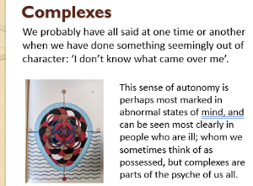
Slide 12 - Complexes
According to Jung, a complex is a partially repressed, emotionally-charged cluster of ideas, memories and feelings, often with an archetypal core that gains autonomy and acts as an ‘animated foreign body’ within the unconscious mind. Complexes can be formed from personal experiences, often around relationships with parents and operate independently of the conscious ego, influencing behaviour, disrupting normal psychological function, and potentially causing psychological disturbances or neuroses.
Through analysis and bringing them to consciousness, the psyche can regain regulatory capacity and individuals can regain a new orientation to the complex, reducing its negative hold. When activated complexes can create a sense of compulsivity, where a person feels driven to act in a certain way or is drawn into old, unchanging patterns of behaviour.
Here are a few examples of a complex:
The classic example of a complex is that of the comedian. They may have not felt protected as a child and have therefore developed a way to fit in or feel safe in the wider community. In their case they make people laugh in order to be popular and be liked. A well documented example is John Cleese as once he got through therapy he said he no longer felt he had to be funny.
The youth who is locked in a desperate power struggle with his father, torn between feelings of guilt, fear and resentment can be immensely helped by the realisation that his personal conflict is a variant of the archetypal struggle that has occurred between fathers and sons down the ages.
Equally, the mother, despairing because her children have grown up and fled the nest can come to terms with the situation when she recognises that what she is suffering is the pain that all mothers have felt when they have to deliver their children to the world as a second ‘parturition’.
An example of the Father complex: A woman whose childhood has been dominated by a tyrannical father, who insisted always on having his own way and made terrifying scenes whenever he was thwarted. The father archetype was activated in this girl’s unconscious by this tyrant, but only partially. The law-giving, authoritarian, commanding aspects of the father complex were built into her personal unconscious whereas the loving, protective and supportive aspects would remain inactivated in her unconscious as unactivated potential.
The result was that this woman, throughout her life, seemed fated to be drawn to angry, bullying, and self-righteous men who she felt she had no alternative but to placate, appease and obey. At the same time there persisted in her an unfulfilled longing for a man who would give her love, support and protection. Unfortunately, she could never find him because she could never get into a relationship with such a man because he was too alien and too essentially unfamiliar to her and she didn’t possess the emotional vocabulary necessary to share such love.
Fortunately, during analysis that all changed. At first she projected the angry father onto the male analyst and misinterpreted his tone and comments believing him to be furious with her for not being a better patient because that is what was familiar to her but as the therapeutic relationship progressed she was able to become conscious of the destructive influence of her father complex to find the strength to stand up to men who undermine or exploit her, integrating some of their authority into her own personality. Gradually a warm trusting relationship developed between her and her analyst freed of negative projections, and so a healthier and more positive father image developed in her psyche and therefore her capacity to relate to kind, decent men was able to improve.
Anthony Stevens: “We may believe we can master our complexes but all too easily we become their slaves. If we wish to liberate ourselves from their influence, the only way is to make them conscious and confront them. This is not an easy matter, however, complexes do not give up their secrets or power very readily and they can display tenacious resistance for the analytic process particularly in people who have deep feelings of insecurity. Such people will be terrified of confronting their complexes and will do anything to deny, project or rationalise them away rather than own them in consciousness.” (Questions & Discussion)
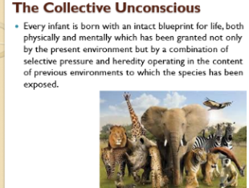
Slide 13 - The collective unconscious
Every infant is born with an intact blueprint for life, both physically and mentally which has been granted not only by the present environment but by a combination of selective pressure and heredity operating in the content of previous environments to which the species has been exposed.
Jung initially described the contents of the collective unconscious as “primordial images” derived from the past history of mankind. When he formally proposed the idea of the collective unconscious many people thought he was referring to something mystical like a group mind or a world soul and this misconception still holds today in some quarters. In fact the collective unconscious is a respectable scientific hypothesis entirely compatible with the theoretical approach of biologists who study animal behaviour in the natural environment.
These scientists (ethologists as they are known) hold that each animal species is uniquely equipped with a repertoire of behaviours adapted to the environment in which it evolves. This repertoire is dependent on innate releasing mechanisms which the animal inherits in its central nervous system and which are primed to become active when appropriate stimuli are encountered in the environment. When these stimuli are met, this innate mechanism is released and the animal responds with a pattern of behaviour.
There are as many archetypes as there are typical situations in life and endless repetition has engraved these experiences in our psychic constitution. In other words we have a blueprint for a likely way of behaving.
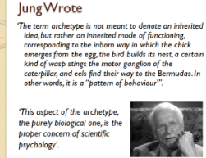
Slide 14 - He wrote: ‘the term archetype is not meant to denote an inherited idea, but rather an inherited mode of functioning, corresponding to the inborn way in which the chick emerges from the egg, the bird builds its nest, a certain kind of wasp stings the motor ganglion of the caterpillar, and eels find their way to the Bermudas. In other words, it is a “pattern of behaviour”. This aspect of the archetype, the purely biological one, is the proper concern of scientific psychology’.
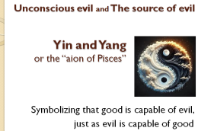
Slide 15 – HOMEOSTASIS
Jung believed that the psyche is a dynamic system functioning in accordance with natural laws. This is the principle of self-regulation and is a means by which biological systems keep themselves in a state of balance in the interests of survival.
As natural environments on our planet are constantly changing, no living organism could have evolved if they hadn’t possessed the capacity to maintain a steady state. Appreciation of the importance of homeostasis goes back to the ancient Greeks and the Chinese Taoists. Hippocrates identified health as a state of harmony existing between man, his vital forces and the environment while the Taoists taught that all reality is permeated by two great opposing yet complimentary masculine and feminine principles, Yin and Yang and that all changes and transformations are due to alternations in the balance between them.
Claude Bernard (1813-78) demonstrated that a state of equilibrium is maintained in the internal environment in all organisms despite wide fluctuations in the external environment, for example the body temperature of a human being remains at 37 degrees Celsius because it is regulated by the Hypothalamus. If the external heat rises, the hypothalamus compensates by arranging for body heat to be lost by increased blood flow through the skin, sweating, panting and a reduction of the basal metabolic rate. Equally falls in external temperature result in increased muscle tone and shivering.
Jung was convinced that the psyche, like the body, was a self-regulating system. It strives perpetually to maintain a balance between opposing propensities while at the same time seeking its own individuation. (Questions & Discussion)
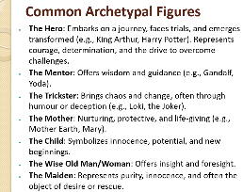
Slide 16 - ARCHETYPES - Common Archetypal Figures
The Archetypes predispose us to approach life and to experience it in certain ways, according to patterns laid down in the psyche.
- Archetypal figures include, mother, father, child
- Archetypal events, such as birth, death, separation
- archetypal objects such as water, the sun, the moon, snakes, and so on.
These images find expression in the psyche, in behaviour and in myths. It is only archetypal images that are capable of being known and coming to consciousness, the archetypes themselves are deeply unconscious and unknowable.
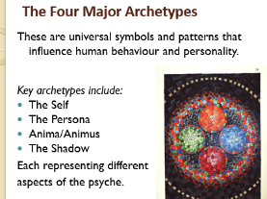
Slide 17 - The Four Major Archetypes
These are universal symbols and patterns that influence human behaviour and personality. Key archetypes include the Self, Persona, the Shadow and the Anima/Animus each representing different aspects of the psyche. These words are derived from Latin meaning relational soul and represents the unconscious part of the male and female psyche. Understanding these archetypes can provide insights into personal development and help navigate life’s challenges.
- The Self
- The Persona
- The Anima/Animus
- The Shadow

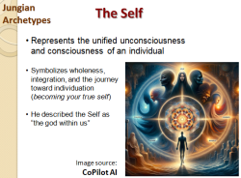
Slide 18 - Jungian Archetypes
The Self
As mentioned before, in Jung’s psychology the Self is the totality of the psyche, representing the unified totality of consciousness and the unconscious mind, and serves as the goal-oriented, central organising principle of the personality. It is a transcendental concept and an archetype that guides the process of individuation, the lifelong journey of personal growth and self-realisation aimed at achieving psychological wholeness and integrating all aspects of the personality.
It acts as the underlying force that organises and structures the personality, bringing about the most appropriate adjustment at each stage of life. This would indicate why ‘rights of passage’ have been used by man for millennia which allow us to incorporate key life experiences and changes while also understanding the need to move on.
The Self is not static, it evolves. The first half of life is building the ego and adapting to the external world. The second half of life is returning to the self, rediscovering inner wholeness and integrating the unconscious, the path to individuation.
Jung places the Self at the centre from which the Ego develops. The Self is often symbolised by archetypal images, such as a circle, square or mandala, to represent its encompassing nature and the order it brings to the psyche. Its goal is wholeness, the complete realisation of the blueprint for human existence within the context of the individual.
He described the Self as “the god within us,” a sacred inner force that reorients us towards balance, meaning, and transformation.
However, Jung warned that the Self’s immense power could lead to inflation or delusion if not approached with humility. It’s the most powerful force in the psyche and must be engaged with care.
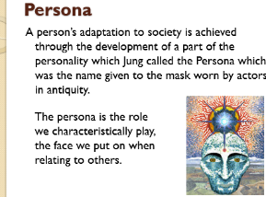
Slide 19 - Persona
A person’s adaptation to society is achieved through the development of a part of the personality which Jung called the Persona which was the name given to the mask worn by actors in antiquity. The persona is the role we characteristically play, the face we put on when relating to others. It is the ‘packaging’ of the ego like the ego’s PR man or woman responsible for advertising to people how one wants to be seen and reacted to. In reality it is a facade and there is always an element of pretence.
Social success depends on the quality of the persona. The best kind of persona to have is one that adapts flexibly to different situations while at the same time being a good reflection of the ego qualities that lie behind it.
Trouble occurs when, for neurotic reasons one tries to assume a persona that does not fit or attempts to keep up some kind of false self which one does not possess the ability to sustain. This appears as a facade hiding all the personality’s insecurities and fears of being found to be defective.
Initially the persona develops out of a need to satisfy the expectations of parents, teachers and society in the course of growing up. Young children quickly learn what is acceptable to parents and will form a personality that gets parental approval and later teachers, peers and society in general. The tendency is to build acceptable traits into the persona and to keep unacceptable traits hidden or repressed in the shadow.

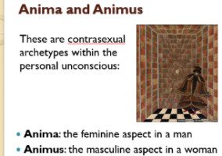
Slide 20 - Anima and animus
These are contra-sexual archetypes within the personal unconscious:
- Anima: the feminine aspect in a man and a man’s ideal image of a woman
- Animus: the masculine aspect in a woman and a woman’s ideal image of a man
These two complexes in the personal unconscious are perhaps the most difficult to understand and the most contentious.
These concepts are derived in part from the archetypes of the feminine and masculine, and in part from the individual’s own life experience with members of the opposite sex beginning with mother and father.
Just as happens with the shadow, these archetypes are met with firstly in projected form. They carry with them the awe-inspiring quality which accounts for falling in love at first sight, which one can think of as a projection in a man on to an unknown woman of an archetypal image and the woman then becomes fascinating and immensely appealing.
While he was influenced by the gender-based thinking of his time, Jung recognised that the “masculine” aspects of the psyche such as autonomy, separateness, and aggression were not superior to the “feminine” aspects such as nurturance, relatedness, and empathy. Rather, they form two halves of a whole, both of which belong to every individual, and neither of which is superior to the other. (Questions & Discussion)
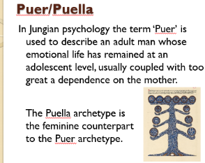
Slide 21 - PUER/PUELLA
Puer aeternis is Latin for ‘eternal boy’. In Greek mythology it designates a child-god who is forever young like Dionysus, or Eros. The theme is immortalised in the modern classics Peter Pan or the picture of Dorian Gray. In Jungian psychology the term ‘puer’ is used to describe an adult man whose emotional life has remained at an adolescent level, usually coupled with too great a dependence on the mother.
The Puella archetype is the feminine counterpart to the Puer archetype. It embodies youthful, creative and unconventional energy, but can also manifest as an avoidance of responsibility, immaturity and a disconnect from reality due to an ‘innocence complex’. The puella is youthful and charming, appealing and seductive; she represents the energetic, the unusual and the wisdom of the feminine in many forms.
To transition into a mature woman she needs psychological growth, self-agency and breaking free from limiting patterns. She leads creative and innovative expression, pointing to the future. When distorted and disturbed however, the development of the psyche is halted until these issues are addressed. She then can’t make the transition to maturity, and she remains a girl in an adult body and she does her best to look and behave younger than he she is.
She may remain in a fantasy world, avoiding the responsibilities and challenges of adulthood, ultimately hindering personal growth and emotional maturation. This prolonged attachment to the idealisation of youth and beauty can prevent the puella from developing a healthy sense of autonomy and maturity.
This archetype of the puella aeterna represents not just a psychological pattern but also a reflection of cultural attitudes towards women’s value often focused on beauty and youth. The challenge for those caught in the grip of the puella archetype is to confront these unrealised dependencies and move toward the fullness of adult life, embracing the responsibilities, wisdom and self-sufficiency that come with it.
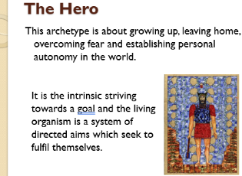
Slide 22 - The HERO
This archetype is about growing up, leaving home, overcoming fear and establishing personal autonomy in the world. It begins to operate as soon as the infant can crawl and drives that intense curiosity which impels all young creatures to explore their environment and usually culminates when a young person is in their twenties and leaves home to go to university or travel and then finding a place to live independently and embark on a career.
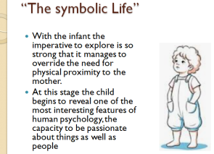
Slide 23 – The Hero “The symbolic Life”
With the infant the imperative to explore is so strong that it manages to override the need for physical proximity to the mother. This exploration begins with the mother functioning as a secure base from which the infant crawls in his heroic excursions. Repeatedly he turns his back on her to go off on a brief adventure, only to reassure him or herself that she is still there. This recurrent to-ing and fro-ing is a paradigm of all subsequent development, a rhythmic cycle of separation and reunion, progress and regression, two steps forward and with luck only one step back.
At this stage the child begins to reveal one of the most interesting features of human psychology, the capacity to be passionate about things as well as people, e.g a soft toy, a piece of blanket, almost anything that can be sucked or cuddled. The psychologist, Winnicott who studied child development called these things Transitional objects. These are symbols of the mother and of special value to the child when going to bed at night or feeling lonely or anxious as they possess the magical power of rendering the absent mother symbolically present. In this way the infant is already distinguishing between fantasy and fact, between inner objects and external objects. They become invested with those emotions which are normally associated with the presence of the mother and with physical contact with her. They are the first indications of the individual’s emerging capacity to live what Jung called “The symbolic Life”.
Fantasy and creativity were very important to Jung. He had an extraordinary rich fantasy life probably due to the fact that he was an introverted intuitive type of person who grew up in an environment which made him experience loneliness and isolation. In Jung’s view fantasy is vital to development because it forms a vital link between inner and outer worlds and is not a form of escape from reality as Freud maintained, but the means by which we grow psychologically. “Life is teleology par excellence”. It is the intrinsic striving towards a goal, and the living organism is a system of directed aims which seek to fulfil themselves. These aims are first tested out in fantasy, dreams and games. They are also tested out in stories and because of their vivid fantasy life children love stories and are particularly susceptible to their influence. (Tea Break – or – Questions & Discussion)
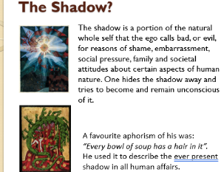
Slide 24 - The Shadow
This carries all the things we do not want to know about ourselves or do not like. Shakespeare has Prospero say in the Tempest “This thing of darkness I acknowledge mine” (He is obviously referring to Caliban the sole inhabitant of the island, a feral, misshapen creature. This quotation shows Prospero recognises a darker aspect within himself, mirroring Caliban’s behaviour or his own capacity for cruelty and power)
“One does not become enlightened by imagining figures of light but by making the darkness conscious” (Jung)
“At all counts the shadow forms an unconscious snag thwarting our most well-meant intentions. It’s as if, like Mr Hyde, there’s another person operating your mental machinery.” (Anthony Stevens).
In Dr Jekyll and Mr Hyde the primary moral is the inherent duality of human nature, emphasising that every person possesses both good and evil within them. The story warns against repressing one’s darker impulses, as this can lead to the evil side gaining control. It also highlights the dangers of unchecked ambition and the importance of moral balance and self-awareness over the pursuit of reputation or the repression of one’s true self. Dr Jekyl’s experiment to separate his good and evil sides shows that this duality is a fundamental part of being human and these two sides are inextricably linked not separate entities. By trying to eliminate the evil in himself Jekyll actually gives it more freedom to act leading to his own destruction. Ignoring or repressing darker impulses can make them stronger.
Like every other major complex, the shadow has its archetypal core:
- the archetype of the enemy
- the treacherous stranger
- the evil intruder
This too becomes part of our adaptive equipment. It becomes active in early life since it is a matter of survival for all young animals to possess a programmed wariness of anything strange which may be potentially hostile, predatory or destructive. We need a certain amount of wariness and distrust of others but there needs to be a balance otherwise if there is too much distrust you can’t form close, intimate relationships.
The Jungian shadow is a part of the psyche that contains everything we repress, deny or disown – traits, desires, impulses, cultural norms and personal experiences, memories that conflict with our conscious identity.
However, it holds beneficial qualities such as untapped creativity and hidden talents. It also contains all sorts of qualities, capacities and potential, which if not recognised and owned, maintain a state of impoverishment of the personality and deprive the person of sources of energy and bridges of connectedness with others.
Most people have beliefs about themselves which form a self-image and an assessment of their capabilities, usually negative. For example, a person may have grown up with the belief that to be assertive is selfish, so he or she goes through life being pushed around by others whilst deep down seething with resentment, which in turn makes him feel guilty. In this case, his potential for assertiveness and his resentment both form part of his shadow. Analysts would challenge his value system, track it back to his origins and help him become more embodied and therefore more in touch with his needs.
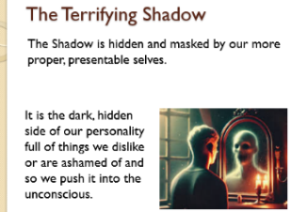
Slide 25 - The Terrifying Shadow
The Shadow is hidden and masked by our more proper, presentable selves. Failing to acknowledge or integrate the shadow can lead to psychological problems, so confronting and accepting it through “shadow work” is crucial for personal growth, energy and a more balanced life. Confronting the shadow can be seen as a necessary spiritual discipline that allows for a more complete and authentic self-experience. It is the dark, hidden side of our personality full of things we dislike or are ashamed of and so we push it into the unconscious. It includes negative emotions like envy, guilt, jealousy, arrogance, sadness, dishonesty, greed and cowardice but also violent impulses and sexual urges.
We prefer to entertain idealised images of ourselves rather than acknowledge our personal deficiencies. It is much easier to blame others for our own shortcomings particularly if we can persuade ourselves that the blame is justified.
It is only when this repression becomes too costly in terms of energy, guilt or anxiety may it give rise to neurotic misery and requires therapeutic intervention. This is one of the commonest reasons why people seek analysis. Analysts need to create a situation where people feel secure enough to examine the dangerous contents of the Shadow.
To own ones’ shadow is a painful and potentially terrifying experience, so much so that we usually protect ourselves from such disturbing awareness by making use of our ego-defence mechanisms and project our shadow onto others and hold them responsible for it. This act of unconscious cunning explains the ancient practice of ostracising and scapegoating. It underlies all kinds of prejudice against those belonging to other groups.
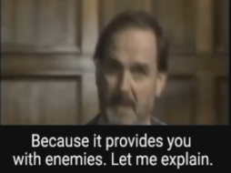
Slide 26 – John Cleese

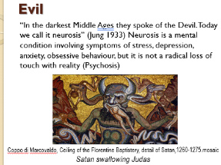
Slide 27 - EVIL
“In the darkest Middle Ages, they spoke of the Devil. Today we call it neurosis” (Jung 1933) Neurosis is a mental condition involving symptoms of stress, depression, anxiety, obsessive behaviour, but it is not a radical loss of touch with reality (Psychosis)
Jung said “The devil describes the grotesque and sinister side of the unconscious for we have never really come to grips with it and it has remained in its original savage state. Probably no one today would still be rash enough to assert that the European is a lamblike creature not possessed by the devil. The frightful record of our age is plain for all to see and they surpass in hideousness everything that any previous age with its feeble instruments, could have hoped to accomplish.”
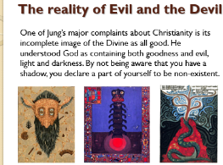
Through shadow projection we are able to turn our enemies into devils and convince ourselves that they are not men and women like us but monsters unworthy of humane consideration. We only need to look at the speeches of Hitler repeatedly use the theme of “untermenschen” or subhumans when referring to Jews and certain other groups of people and so the only thing to do with such vermin was to exterminate them. By skilful use of the Nazi propaganda machine, he was able to induce a sizeable portion of the German population to project its shadow onto these subhumans. What makes propaganda so devastating in its psychological consequences is that it can activate the archetype of evil which may then be projected onto an enemy in addition to the personal shadow. The combined projection then functions as a justification for the slaughter which ensues.
Slide 28 - The reality of Evil and the Devil
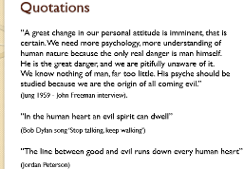
One of Jung’s major complaints about Christianity is its incomplete image of the Divine as all good. He understood God as containing both goodness and evil, light and darkness. By not being aware that you have a shadow, you declare a part of yourself to be non-existent. We prefer to localise the evil in individual criminals while washing our hands in innocence and ignoring the general proclivity to evil. This sanctimoniousness cannot be kept in the long run because the evil lies within us.
Slide 29 - Quotations
“A great change in our personal attitude is imminent, that is certain. We need more psychology, more understanding of human nature because the only real danger is man himself. He is the great danger and we are pitifully unaware of it. We know nothing of man, far too little. His psyche should be studied because we are the origin of all coming evil.” (Jung 1959 - John Freeman interview).
“In the human heart an evil spirit can dwell” (Bob Dylan song ‘Stop talking, keep walking’)
“The line between good and evil runs down every human heart” (Jordan Peterson)
(Questions & Discussion)
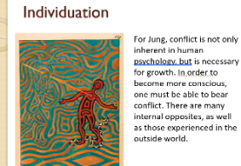
Slide 30 - Individuation
Jung regarded this as the highest of all human attainments. The development of the personality whereby an individual becomes as complete a human being as is possible for him or her to be. The idea of Individuation is by no means new. Interest in the ‘principum individuationis’ (a concept describing the fundamental nature of how a thing becomes a distinct individual, separate from other things, and is thus quantifiable and identifiable) has occurred throughout the history of western philosophy since the time of Aristotle. It is to be found in the work of Aquinas, Leibniz, Spinoza, Locke and Schopenhauer but the latter focused on the conscious aspects of the human process whereas Jung considered ‘self-actualisation to be a property of all living things.
He wrote: “Individuation is an expression of that biological process, simple or complicated as the case may be, in which every living organism becomes what it is destined to become from the beginning.” He eventually concluded that a similar principle was at work in inorganic matter as well, but it is in humans that individuation finds its highest expression.
As part of the order of nature and because it is a natural homeostatic system, the psyche possesses the power to heal itself, and this is why dreams are so important, particularly series of dreams. In them one can perceive natural processes of healing and individuation taking place. For this reason it is helpful to attend to one’s dreams, but it isn’t necessary to have them analysed. The mere act of writing them down or illustrating them greatly enhances their effect on ego-consciousness. Dreams clearly perform a vital function because we all have them as well as all mammals, and when humans are deprived of dream sleep for any length of time, they become disorientated, hallucinated and deluded.
Jung thought that the probability for their function, in all species that dream, is to integrate the program for life laid down in the genome (i.e. the entire genetic constitution of the species) with the daily experience of the individual.
Anthony Stevens: “Individuation involves the progressive integration of the unconscious timeless self in the personality of the time-bound individual. And since the human psyche is itself a product of nature, it follows that individuation is a biological phenomenon proceeding in a cosmic context.”
The kind of individuation that was the focus of Jung’s attention was the process consciously lived and actively participated in by the committed ego. This is the individuation that Jung saw to be the responsibility of the second half of life and ego-consciousness is crucial to its fulfilment as collaborator, co-author and grateful recipient of all that the unconscious may offer. This is the initiation which is ushered in by the mid-life crisis, the time at which many people ‘wake up’.
Involvement in life during the first 35 or 40 years is usually so wholehearted that it is possible to live out the life cycle quite unreflectingly and still experience the joys of achievement, but if one goes on living into the second half without becoming conscious of oneself existentially, then one is missing the point. To choose individuation is to wake up to the prospect of ageing, to grow accustomed to the sound of time’s winged chariot hurrying near, to accept one’s achievements and failures, weaknesses and strengths and to prepare to abandon the youthful ego-centred state for the mature state of ego-transcendence. Then the original promise of one’s conception may be achieved to become as complete a human being as it is in one to be.

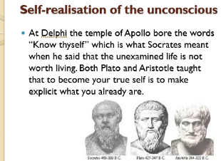
Slide 31 – Self-realisation of the unconscious
Like individuation itself, the idea that each of us is but a pale replica of our potential Self is ancient. Anthony Stevens: “When Pindar advised ‘Become what thou art’, he meant abandon your superficial persona, your social clichés, your worldly habits, and discover the ideal human being latent in your soul.”
At Delphi the temple of Apollo bore the words “Know thyself” which is what Socrates meant when he said that the unexamined life is not worth living. Both Plato and Aristotle taught that to become your true self is to make explicit what you already are.
Jung was indebted to these sources, as indeed he was to the great European discoverers of the unconscious of which Shopenhauer was one. On the basis of his own experience during the years after his break with Freud, he asserted that individuation could be achieved by opening oneself to a profound experience of one’s own unconscious processes. He summed it up in the first sentence of his autobiography “Memories, Dreams and Reflections” which he commenced at the age of 82,
“My life is a story of self-realisation of the unconscious.”
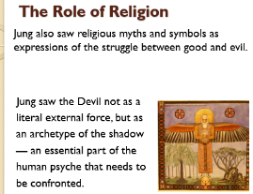
Slide 32 - The Role of Religion
Jung was highly controversial and even confrontational in his writings on religion. In his work Answer to Job (1952) his interpretation of the biblical work is one of his most provocative and spiritually daring works.
In this manuscript he presents the Book of Job as a pivotal event where God, through Job's suffering and moral confrontation, begins to become conscious of His own moral inconsistency and dark side, the shadow or Satan. Jung argues that God, initially an unconscious, dualistic being, becomes aware of His evil counterpart, Satan, and the suffering He caused Job. Jung interprets the incarnation of Christ not as a sacrifice for human sin, but as God’s attempt to atone for his moral failure toward Job. This reframes the Christian narrative as a divine act of repentance. By confronting God's injustice, Job elevates himself above the divine and forces God to see His own flaws. (Google AI)
The drama between Job and Yahweh mirrors the tension between ego and unconscious, between man and his own inner divinity. It is a model for how humans must wrestle with divine injustice and integrate their own shadow.
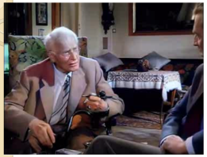
Slide 33 - God
We will finish with Jung as he answers the question: ‘His belief in god?’
And, did you believe in God?
Oh yes.
Do you now believe in God?
Now? Difficult to answer.
I know, I don’t need to believe, I know.

Bibliography  On Jung - Anthony Stevens1990 Penguin books  Jung - A very short introduction 1994  C.G. Jung Good on Evil – Murray Stein  https://en.wikipedia.org/wiki/Carl_Jung  https://www.essentiafoundation.org/  Gail Lonngi, The Nautilus – Student Newspaper  Jung’s model of the psyche, By Ann Hopwood  https://fleurmach.com/2016/07/05/carl-jung-on-the-projection-of-evil | AI references:  Microsoft CoPilot  Google AI  Chat GPT

